# Thermal Control

Thermal control will be in charge of providing energy and controlling all thermal regulating components of the Water Quality Monitoring (Rastaban) device fluids.

# The modules

The Thermal control consists of three power modules:

1. Power Resistor
2. Fan
3. Peltier module

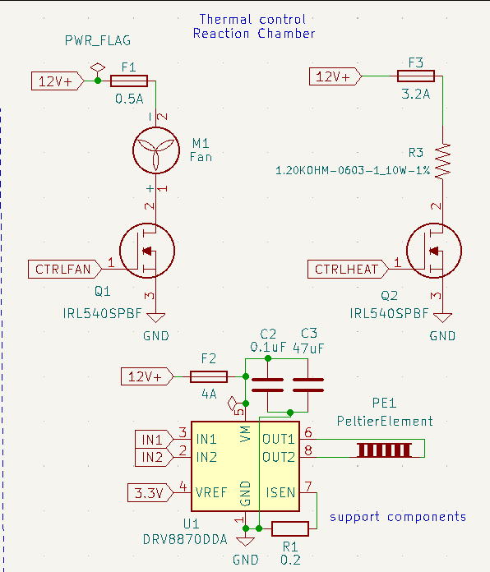These modules are here to increase or lower the temperature of fluid that would be examined. The modules will be drawing very high currents (2A and higher) and therefore these powerlines need to be controlled and protected with care.

# The circuit

To control and protect the module and PCB from damage we need to building some passive protection. That’s why I chose some fuses that are 1.25 times the value of the maximum current the module is supposed to use. When this value Is exceeded, the fuse will blow and the current will stop flowing.

The power mosfet used is the **IRL540SPBF.** This NPN mosfet is designed to be controlled by a 3.3V logic level signal, which the raspberry pi uses as well. The mosfet is able to switch 20A and that’s why the component may seem overspecced. However, by using a higher current mosfet (lower RDS-on) there is higher efficiency because less energy is converted into heat. This also means extra cooling components (heatsinks) are required for the mosfet.

For the peltier module we used a H-bridge since the peltier module can cool or heat the same side when current is reversed. The module can help reaching higher temperatures in combination with the power resistor. When the current is reversed cooling the same surface can be achieved.

# EMC

EMC or electromagnetic compatibility is a significant part of every PCB design. We don’t want the high currents that flow through these components to disrupt the signals lines. Therefore I need to consider the position of the power wires.